**­­­**

Class 7

**Lecture 30**

**MS Access-**

**Primary Key, Foreign key, Relationship**

**MS Access**



**Lab Objectives:**

* Primary key constraints.
* Foreign key constraints
* Adding Data to existing Table.

**Primary Key**

The PRIMARY KEY constraint uniquely identifies each record in a database table. Primary keys must contain UNIQUE values, and cannot contain NULL values. A table can have only one primary key, which may consist of single or multiple fields.

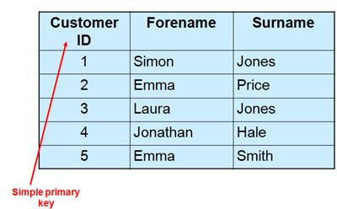

**Foreign Key**

A FOREIGN KEY is a key used to link two tables together. A FOREIGN KEY is a field (or collection of fields) in one table that refers to the PRIMARY KEY in another table.

Notice that the "PersonID" column in the "Orders" table points to the "PersonID" column in the "Persons" table.

The "PersonID" column in the "Persons" table is the **PRIMARY KEY** in the "Persons" table.

The "PersonID" column in the "Orders" table is a **FOREIGN KEY** in the "Orders" table.

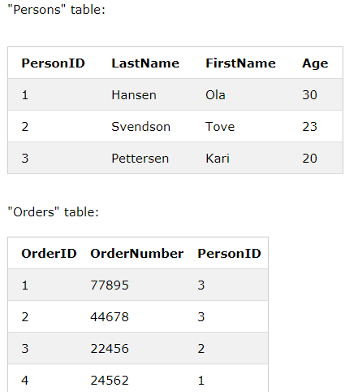

**Primary Key VS Foreign Key**

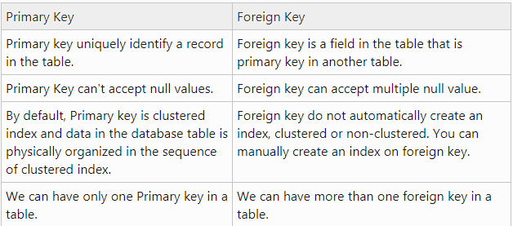

# Relationship

Access allows you to create relationships between tables so that you can query related data from multiple tables..

In relational database terms, a relationship is a situation where multiple tables can contain related data that is linked by a common field. A relationship consists of a parent table and a child table. The child table references the parent table by having a field that matches a field in the parent table. The child's field is referred to as a foreign key. The parent's field is the primary key. In a relationship, any data entered into the child's foreign key field must match a value from the parent's primary key field.

**Types of Relationships**

* **One-to-One**

A row in table A can have only one matching row in table B, and vice versa.

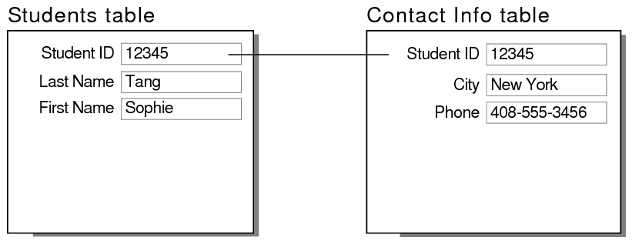

* **One-to-Many (or Many-to-One)**

A row in table A can have many matching rows in table B, but a row in table B can have only one matching row in table A.

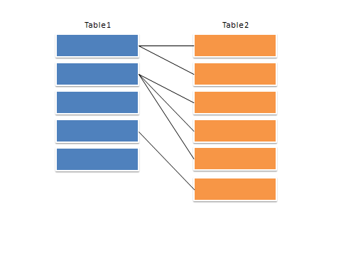

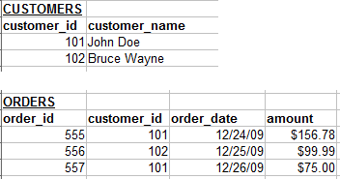

* **Many-to-Many**

A row in table A can have many matching rows in table B, and vice versa. This is achieved through the use of a third table (commonly called a junction table) that contains lookup data for both tables.

